8. Scenario: You are a data scientist working for a company that sells products online. You have

been tasked with analyzing the sales data for the past month. The data is stored in a Pandas data

frame.

Question: How would you find the top 5 products that have been sold the most in the past month?

Code:

import pandas as pd

df = pd.read_csv(r"C:\Users\jampa\Downloads\monthly_sales_data.csv")

df['Order Date'] = pd.to_datetime(df['Order Date'])

recent_sales = df[df['Order Date'] >= pd.Timestamp.today() - pd.Timedelta(days=30)]

product_sales = recent_sales.groupby('Product Name')['Quantity Sold'].sum()

top_5_products = product_sales.sort_values(ascending=False).head(5)

print("Top 5 products sold in the past month:")

print(top_5_products)

output:

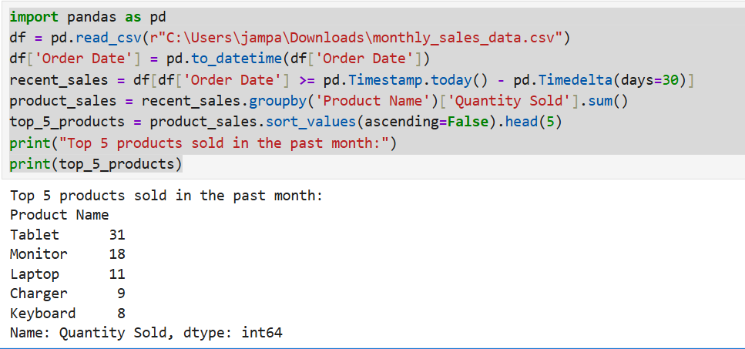

Dataset:

|  |  |  |
| --- | --- | --- |
| Product Name | Order Date | Quantity Sold |
| Keyboard | 3/30/2025 | 3 |
| Monitor | 4/5/2025 | 5 |
| Monitor | 3/26/2025 | 4 |
| Monitor | 3/21/2025 | 1 |
| Tablet | 4/17/2025 | 5 |
| USB Cable | 4/1/2025 | 2 |
| Keyboard | 4/15/2025 | 2 |
| Monitor | 4/24/2025 | 1 |
| USB Cable | 3/25/2025 | 3 |
| Mouse | 4/11/2025 | 2 |
| Tablet | 4/19/2025 | 1 |
| Tablet | 4/23/2025 | 1 |
| Tablet | 4/4/2025 | 2 |
| Charger | 3/22/2025 | 3 |
| Monitor | 4/26/2025 | 3 |
| Tablet | 4/14/2025 | 3 |
| Charger | 4/25/2025 | 3 |
| Tablet | 4/10/2025 | 5 |
| USB Cable | 3/29/2025 | 2 |
| Charger | 4/4/2025 | 2 |
| Tablet | 4/23/2025 | 4 |
| Keyboard | 3/26/2025 | 5 |
| Mouse | 3/30/2025 | 4 |
| Charger | 4/5/2025 | 3 |
| USB Cable | 4/29/2025 | 5 |
| Keyboard | 4/9/2025 | 5 |
| Smartphone | 3/25/2025 | 4 |
| Tablet | 3/26/2025 | 4 |
| USB Cable | 4/10/2025 | 1 |
| Keyboard | 4/20/2025 | 1 |
| Smartphone | 3/27/2025 | 5 |
| Charger | 3/20/2025 | 1 |
| Smartphone | 4/29/2025 | 2 |
| Monitor | 4/10/2025 | 1 |
| Laptop | 4/15/2025 | 1 |
| Laptop | 4/17/2025 | 5 |
| Laptop | 3/28/2025 | 5 |
| Tablet | 4/25/2025 | 1 |
| Smartphone | 3/24/2025 | 2 |
| Tablet | 4/26/2025 | 4 |
| Mouse | 3/26/2025 | 5 |
| Laptop | 4/20/2025 | 5 |
| Mouse | 4/25/2025 | 4 |
| USB Cable | 3/22/2025 | 4 |
| Tablet | 3/20/2025 | 2 |
| Monitor | 4/16/2025 | 5 |
| Monitor | 4/19/2025 | 3 |
| Smartphone | 3/22/2025 | 4 |
| Tablet | 4/7/2025 | 5 |
| Charger | 4/10/2025 | 1 |
|  |  |  |
|  |  |  |